Assignment 3 (SSIS Flights Transactional Data)
WD1:
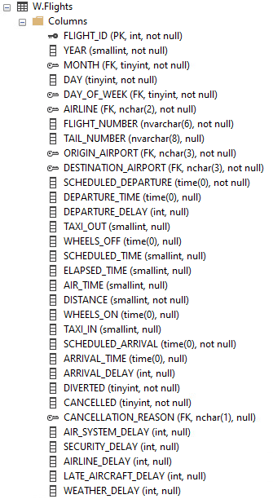

WD2:
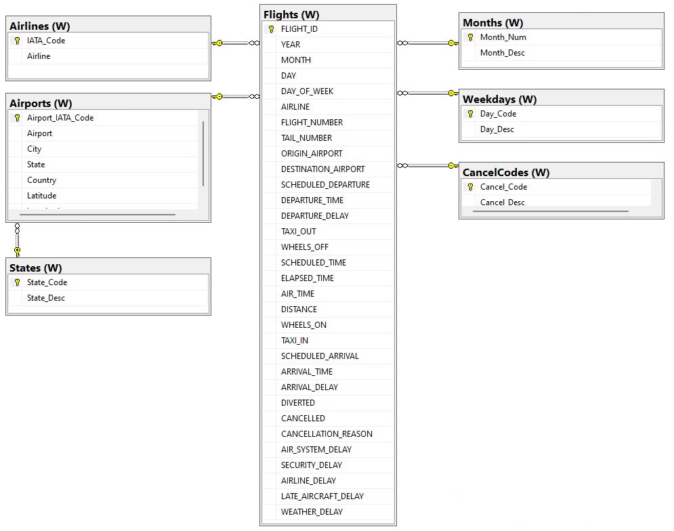

WD3:
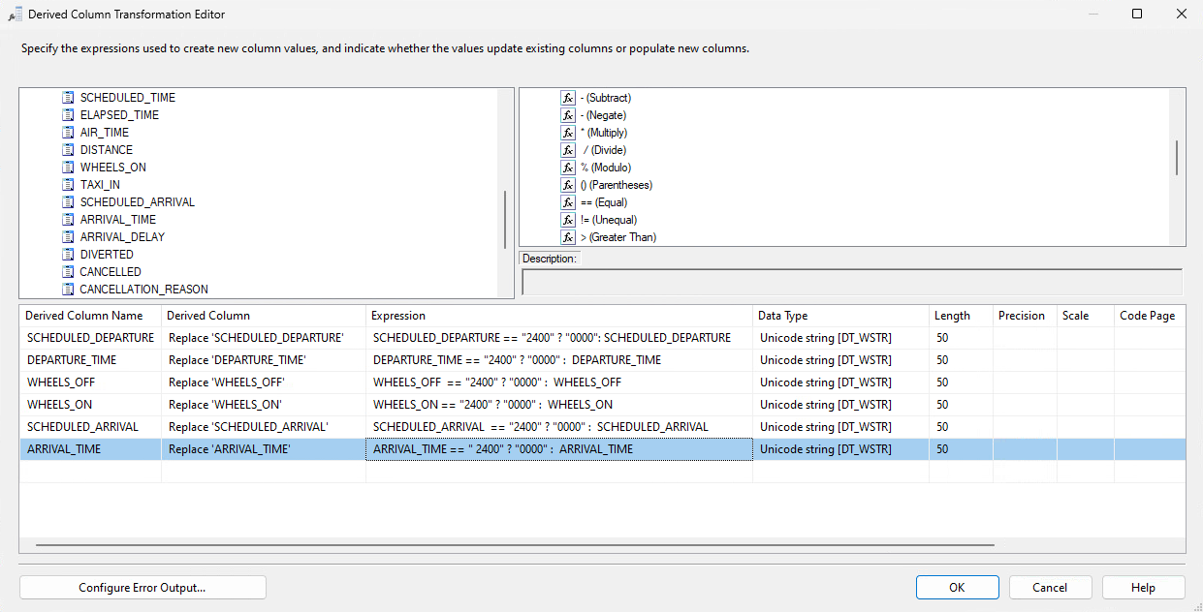
WD4:
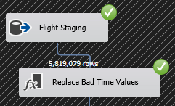
WD5:
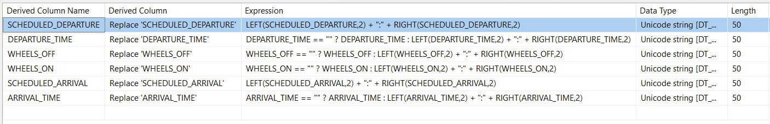

WD6:
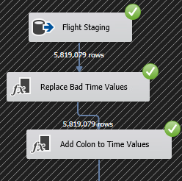

WD7:
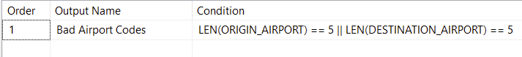
WD8:
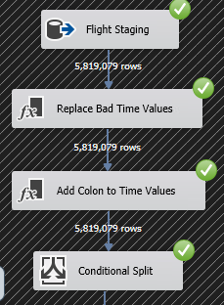

WD9:
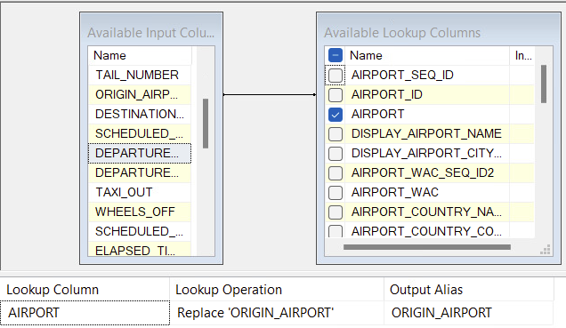
WD10:
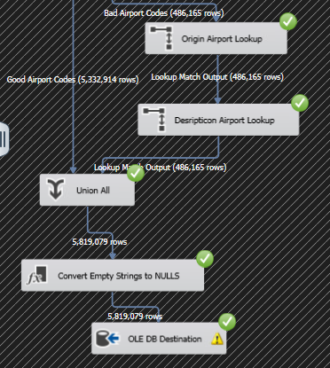
WD11:
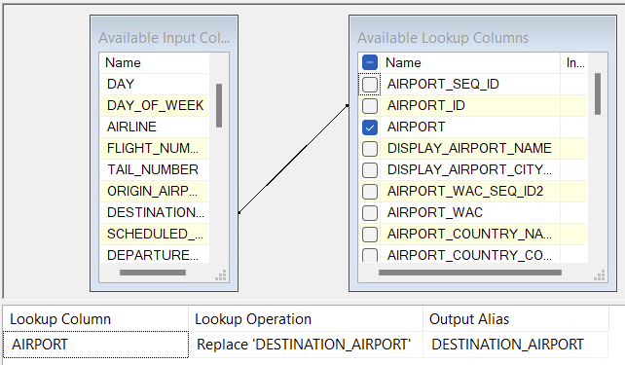
WD12:
WD13:
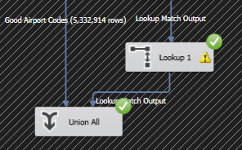
WD14:
Unicode string (DT_WSTR) value that is NULL, with a maximum length of 50 characters.
WD15:
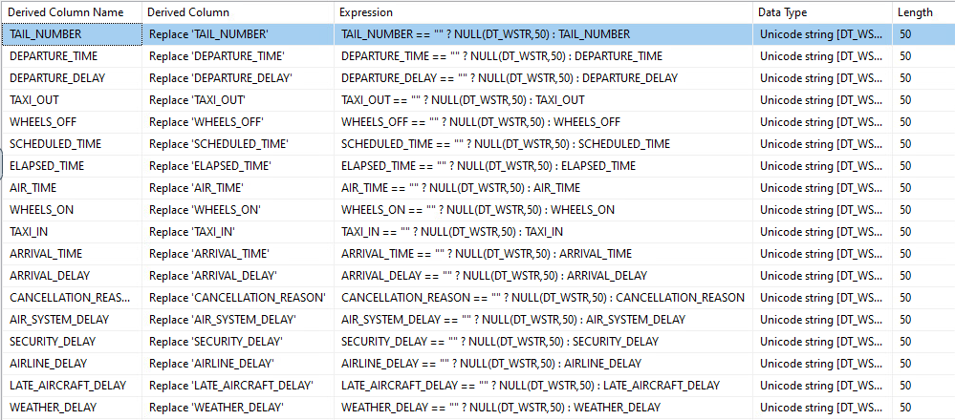
WD16:

WD17:
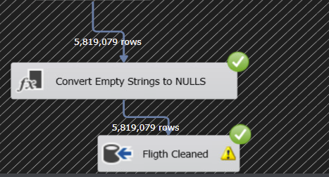
WD18:
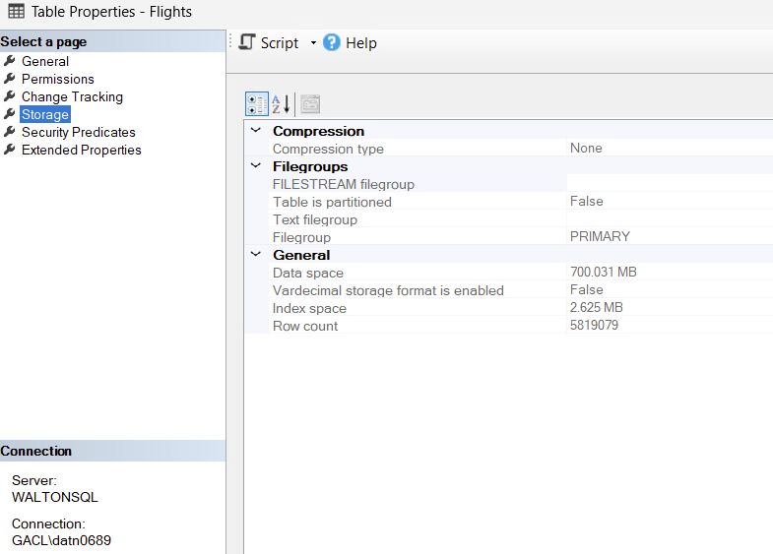
WD19:
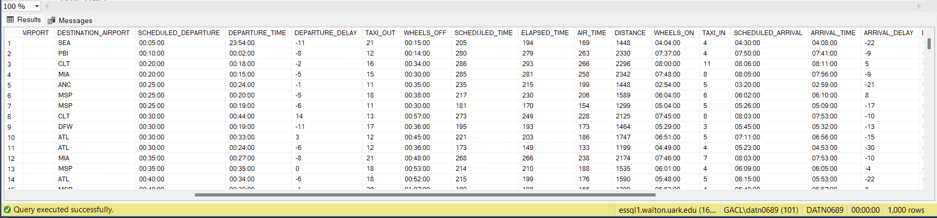

WD20:
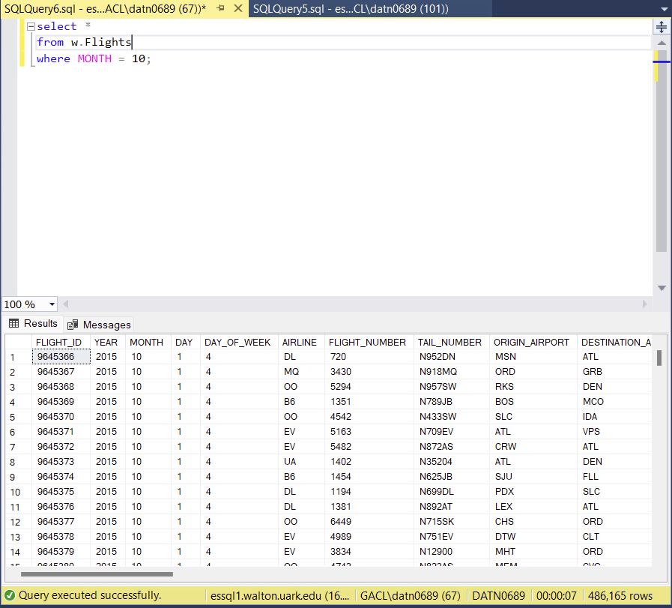
WD21:
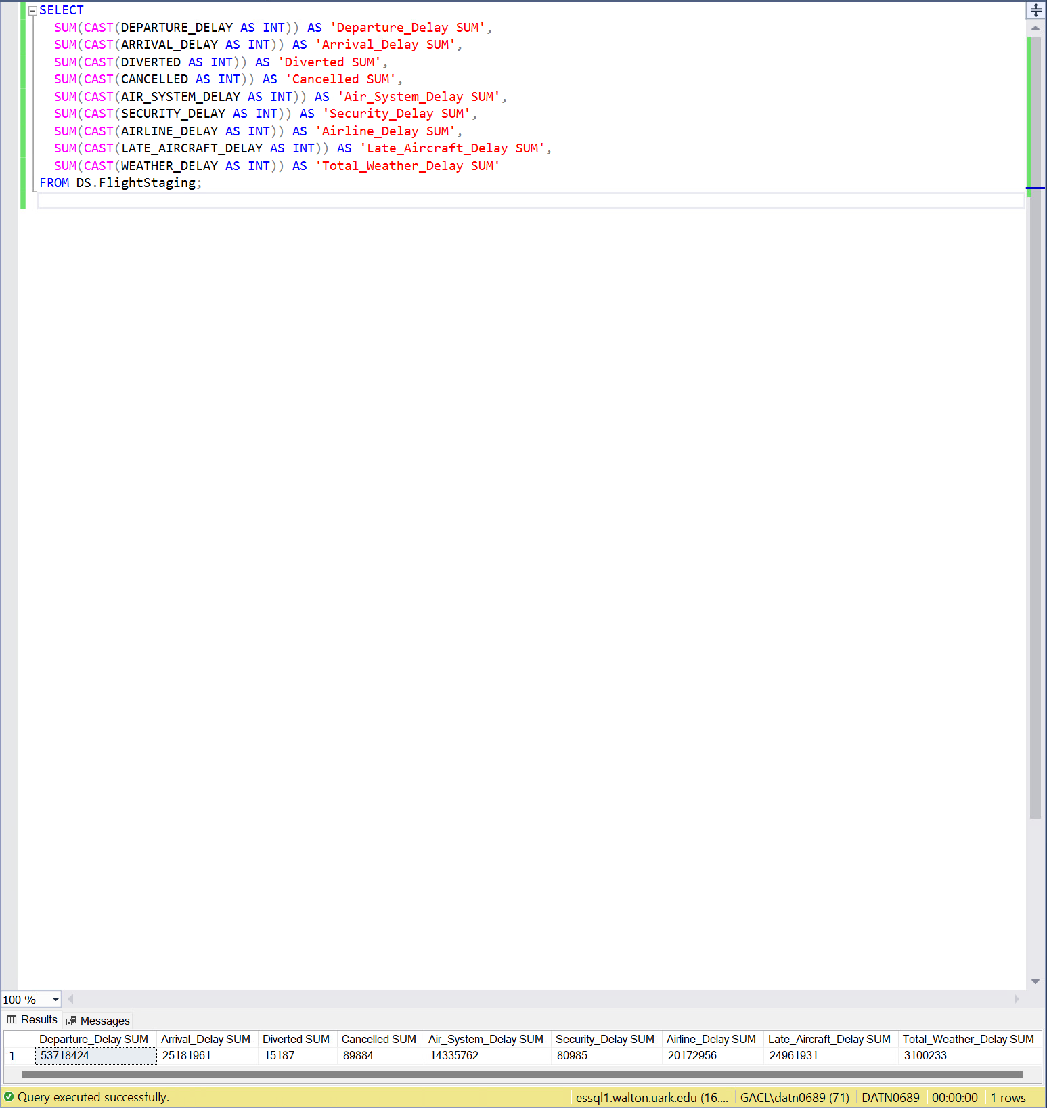
WD22:
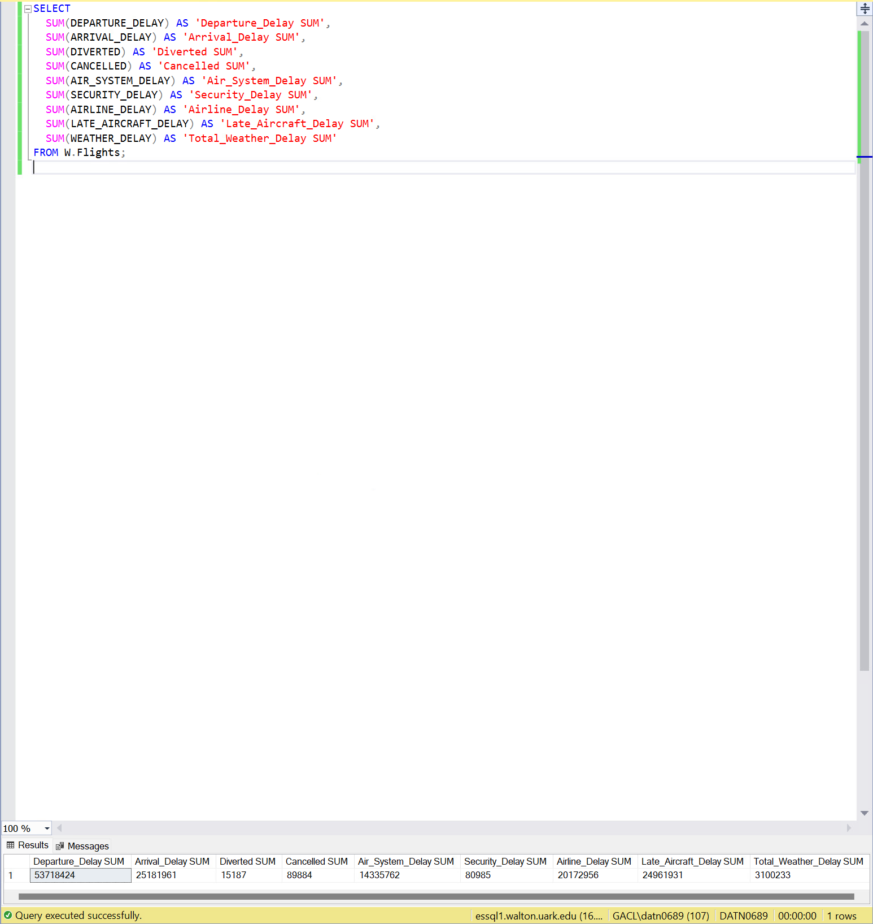
WD23:
All numeric values for delays, cancellations, and diversions were successfully cleaned, cast, and transferred during the ETL process.
WD24:
The data is not loaded directly to the worksheet rows. Instead, it is stored in the Excel Data Model, which allows for creating relationships and analyzing the data using PivotTables and PivotCharts.
WD25:
